TestNg 1

Code:

package com.example;

import org.testng.annotations.AfterMethod;

import org.testng.annotations.BeforeMethod;

import java.util.List;

import java.util.Set;

import org.openqa.selenium.By;

import org.openqa.selenium.JavascriptExecutor;

import org.openqa.selenium.WebDriver;

import org.openqa.selenium.WebElement;

import org.openqa.selenium.chrome.ChromeDriver;

import org.openqa.selenium.support.ui.Select;

import org.testng.annotations.Test;

import io.github.bonigarcia.wdm.WebDriverManager;

/**

* Unit test for simple App.

*/

public class AppTest

{

/**

* Rigorous Test :-)

*/

WebDriver driver;

@BeforeMethod

public void setup() throws InterruptedException{

WebDriverManager.chromedriver().setup();

driver =new ChromeDriver();

driver.get("https://economictimes.indiatimes.com/et-now/results");

driver.manage().window().maximize();

}

@Test

public void shouldAnswerWithTrue() throws InterruptedException

{

WebElement mutualFunds=driver.findElement(By.xpath("/html/body/main/div[4]/nav/div[10]/a"));

mutualFunds.click();

Thread.sleep(2000);

driver.findElement(By.xpath("/html/body/section/main/aside/div[4]"));

JavascriptExecutor js=(JavascriptExecutor)driver;

js.executeScript("window.scrollBy(0,900)");

Thread.sleep(5000);

Select dropdown=new Select(driver.findElement(By.xpath("/html/body/section/main/aside/div[4]/div[2]/select")));

dropdown.selectByVisibleText("Canara Robeco");

Thread.sleep(2000);

Select scheme=new Select(driver.findElement(By.xpath("/html/body/section/main/aside/div[4]/div[3]/div/select")));

scheme.selectByVisibleText("Canara Robeco Bluechip Equity Direct-G");

Thread.sleep(2000);

driver.findElement(By.linkText("Get Details")).click();

// Switch to the new tab

Set<String> windowHandles = driver.getWindowHandles();

for (String handle : windowHandles) {

if (!handle.equals(driver.getWindowHandle())) {

driver.switchTo().window(handle);

}

}

Thread.sleep(2000);

driver.findElement(By.xpath("/html/body/main/div[10]/section[1]/div/div[2]/div[1]/div[2]")).click();

driver.findElement(By.xpath("/html/body/main/div[10]/section[1]/div/div[2]/div[1]/div[2]/ul/li/ul/li[1]/span")).click();

Thread.sleep(2000);

driver.findElement(By.xpath("/html/body/main/div[10]/section[1]/div/div[2]/div[1]/div[3]/ul/li/span")).click();

driver.findElement(By.xpath("/html/body/main/div[10]/section[1]/div/div[2]/div[1]/div[3]/ul/li/ul/li[3]/span")).click();

Thread.sleep(2000);

driver.findElement(By.xpath("/html/body/main/div[10]/section[1]/div/div[2]/div[1]/div[4]/ul/li/span")).click();

driver.findElement(By.xpath("/html/body/main/div[10]/section[1]/div/div[2]/div[1]/div[4]/ul/li/ul/li[4]/span")).click();

driver.findElement(By.xpath("/html/body/main/div[10]/section[3]/div/ul/li[2]")).click();

driver.findElement(By.xpath("/html/body/main/div[10]/section[5]/div/div[1]/section[1]/div[2]/div[1]/ul/li[1]"));

WebElement rowelement=driver.findElement(By.xpath("//*[@id='mfReturns']/div[2]/div[2]/ul/li[1]/table/tbody/tr[1]"));

List<WebElement> li=rowelement.findElements(By.xpath(".//td"));

for(WebElement r:li)

{

System.out.println(r.getText());

}

Thread.sleep(5000);

}

@AfterMethod

public void closemethod(){

driver.quit();

}

}

OUTPUT:

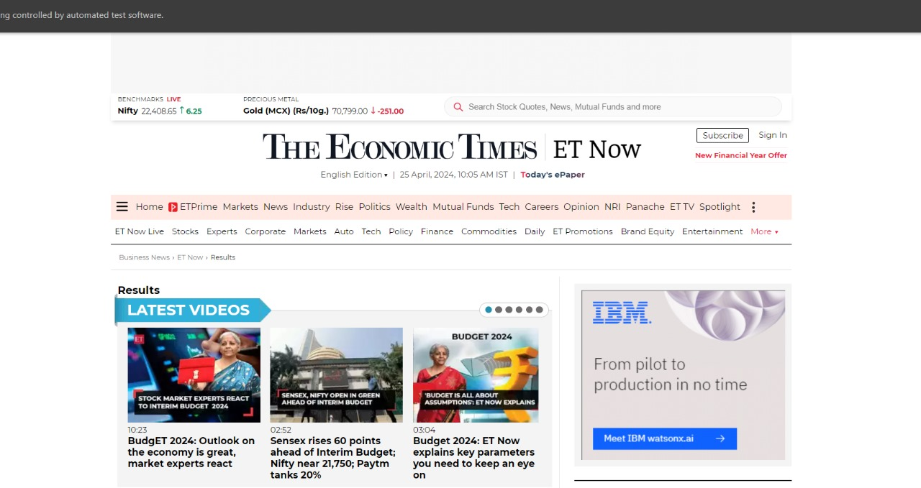

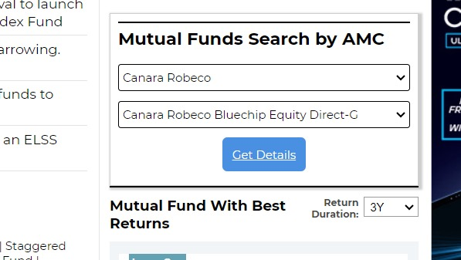

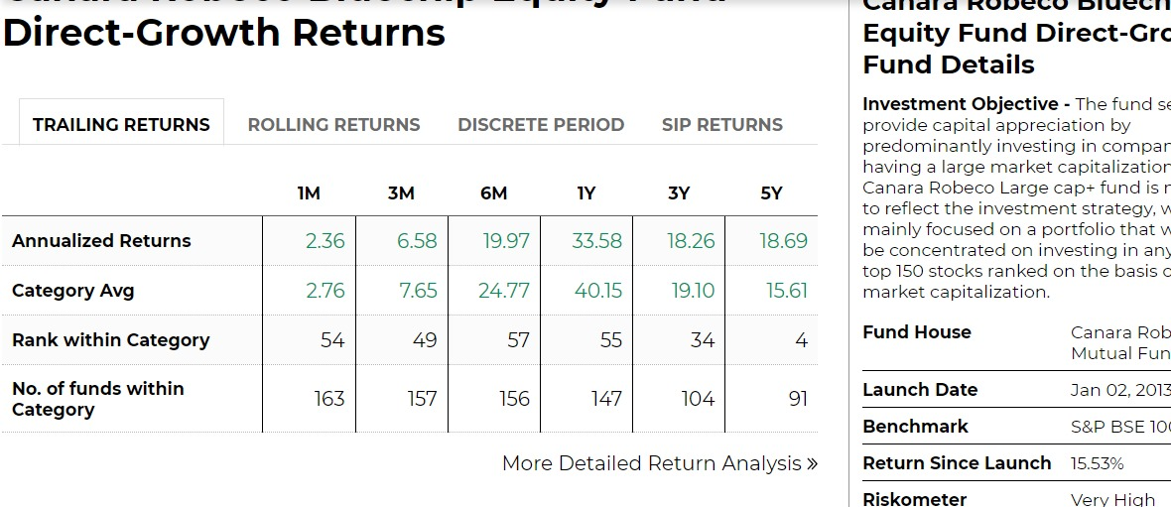

TestNg 2

CODE:

package com.iamneo;

import org.testng.annotations.AfterMethod;

import org.testng.annotations.BeforeMethod;

import org.openqa.selenium.chrome.ChromeDriver;

import org.openqa.selenium.interactions.Actions;

import org.openqa.selenium.support.ui.ExpectedConditions;

import org.openqa.selenium.support.ui.Select;

import org.openqa.selenium.support.ui.WebDriverWait;

import org.testng.annotations.Test;

import java.time.Duration;

import org.openqa.selenium.By;

import org.openqa.selenium.JavascriptExecutor;

import org.openqa.selenium.Keys;

import org.openqa.selenium.WebDriver;

import org.openqa.selenium.WebElement;

import io.github.bonigarcia.wdm.WebDriverManager;

/**

* Unit test for simple App.

*/

public class TestNg2

{

/**

* Rigorous Test :-)

*/

WebDriver driver;

WebDriverWait wait;

@BeforeMethod

public void setup(){

WebDriverManager.chromedriver().setup();

driver =new ChromeDriver();

driver.get("https://www.moneycontrol.com/");

wait=new WebDriverWait(driver,Duration.ofSeconds(10));

}

@Test

public void shouldAnswerWithTrue() throws InterruptedException

{

wait.until(ExpectedConditions.visibilityOf(driver.findElement(By.xpath("/html/body"))));

Thread.sleep(10000);

WebElement element=driver.findElement(By.xpath("/html/body/div[3]/header/div[1]/div[1]/div/div/div[2]/div/div/form/input[5]"));

element.click();

element.sendKeys("Reliance Industries");

Thread.sleep(5000);

element.sendKeys(Keys.ENTER);

driver.findElement(By.xpath("/html/body/div[8]/div[3]/div[2]/div/table/tbody/tr[4]/td[1]/p/a/strong")).click();

JavascriptExecutor j=(JavascriptExecutor) driver;

j.executeScript("window.scrollBy(0,300)");

Thread.sleep(5000);

WebElement mutualfunds=driver.findElement(By.linkText("Mutual Funds"));

Actions actions=new Actions(driver);

actions.moveToElement(mutualfunds).perform();

Thread.sleep(5000);

WebElement sip=driver.findElement(By.linkText("SIP Return"));

sip.click();

Thread.sleep(5000);

Select dropdown=new Select(driver.findElement(By.xpath("//*[@id='ff_id']")));

dropdown.selectByVisibleText("Axis Mutual Fund");

Select drop=new Select(driver.findElement(By.xpath("//*[@id='im_id']")));

drop.selectByIndex(3);

driver.findElement(By.xpath("//*[@id='invamt']")).sendKeys("100000");

Select period=new Select(driver.findElement(By.xpath("//*[@id='frq']")));

period.selectByVisibleText("Monthly");

driver.findElement(By.xpath("//*[@id='stdt']")).sendKeys("2021-08-02");

driver.findElement(By.xpath("//*[@id='endt']")).sendKeys("2023-08-17");

driver.findElement(By.xpath("//*[@id='mc_mainWrapper']/div[2]/div/div[3]/div[2]/div[2]/form/div[8]/input")).click();

WebElement r1=driver.findElement(By.xpath("//*[@id='mc_mainWrapper']/div[2]/div/div[3]/div[2]/div[6]/table/tbody/tr[1]"));

System.out.println(r1.getText());

WebElement r2=driver.findElement(By.xpath("//*[@id='mc_mainWrapper']/div[2]/div/div[3]/div[2]/div[6]/table/tbody/tr[3]"));

System.out.println(r2.getText());

}

@AfterMethod

public void closemethod(){

driver.quit();

}

}

OUTPUT:

